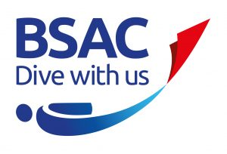
Boatshed and Equipment Storage Access
You may only have access to the boatshed once you have read and signed this document:
- Access is only allowed with the permission of the Diving Officer (to ensure numbers are limited and for contact tracing).
- Access is not permitted if you are displaying any symptoms as listed by the NHS: https://www.nhs.uk/conditions/coronavirus-covid-19/symptoms/
- Thorough hand washing or sanitising must be completed on entering and exiting the building. [Hand washing/sanitiser are located …]
- No more than <insert current local limit> households are permitted within the building at any one time.
- Social distancing guidance must always be adhered to throughout visiting the building.
- Unnecessary touching of equipment or surfaces must be avoided. If you do touch any equipment or surfaces you must wipe it down with the anti-bacterial wipes provided.
- Only the kit marked with tags is sanitised and ready to be used/given out. Make sure you remove the tag if you are giving the kit out.
- Upon receiving or returning used equipment ensure there is no tag and store the equipment in the designated ‘used’ area ready for cleaning. Cleaning of equipment will be completed by the compressor and/or kit officers who will wash the equipment in free free-flowing waters or in separate water to other equipment, before soaking the equipment in an appropriate disinfectant solution for 10 minutes and allowing to dry for 72 hours before the next use. Once this is complete the relevant officer will place the equipment in the relevant location and attach a tag to indicate it has been sanitised and is ready for use.
- Do not breathe from kit to see if it is working, instead use the purge button.
- To ensure social distancing is adhered to at all times, do not pass kit directly to another individual, instead direct them to where it is stored or place it and take a few steps back while they collect it. Avoid handling any mouthpieces or any gas inlets on regulators/cylinders
- Members with keys must make sure anyone they allow access has also signed/e-signed this document.

I understand that to access the club boatshed and use club kit I must follow the guidelines above.
Name: ________________________

Signature: _____________________

Date: _________________________

